- First command to create angular project is
Command is “ng new my-first-app –no-strict –standalone false –routing false”
Here no strict we use so that angular should not be strict and standalone for now
keep it as false and then routing also we need to keep it as false.
- Index.html file is served by the server.
- First code is executed is from main.ts file and in the main.ts file they mention about bootstrap module.
- 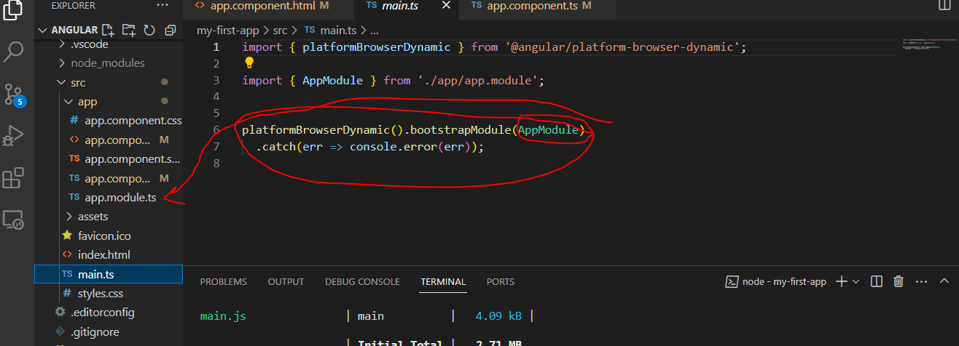
- The main.ts file will point to appmodule.
- 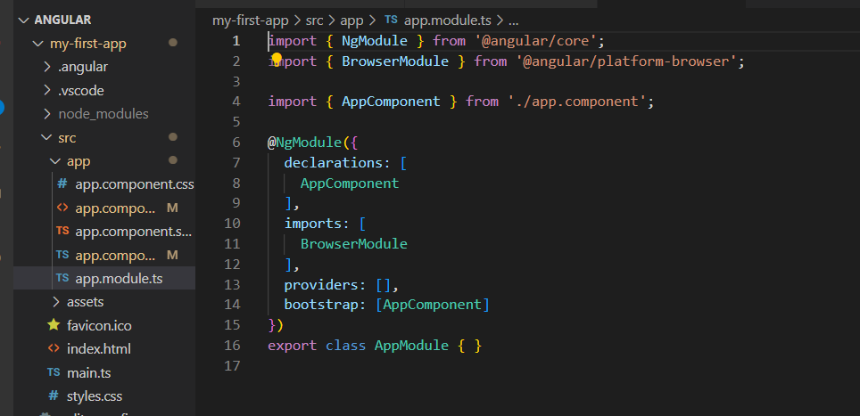
- Here bootstrap arrays lists all the components which should be known to angular at the point of time when it analysis our index.html.
- First when angular starts with main.ts file will run and this main.ts file will show the appmodule and in appmodule.ts file will have the bootstrap array which tells it has appcomponent and so whenever angular sees the appcomponent module from app.module.ts file it will understand that there is a component files such as app component.ts,appcompoenent.html and css so it will check the app component,ts file from there we define selector as approot , now angular is able to handle approot in index.html file
- 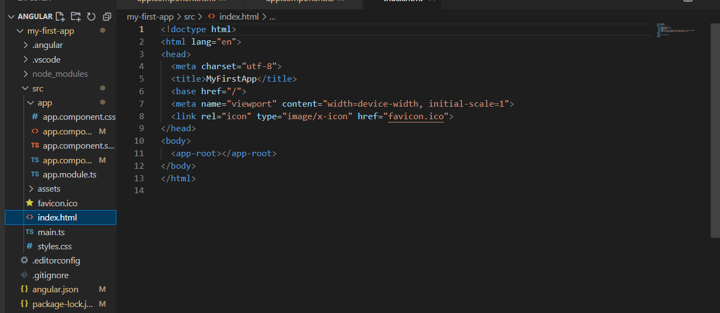
- From here angular will understand that this is the selector listed in the appcomponent so angular will insert the html code written in the appcomponent.html file
- So from the index.html file angular will understand that there is approot selector which is defined in the appcomponent file then it will replace the entire html code which is written in appcomponent.html file. So approot will tell that you need to replace appcomponent file that might html or css but for now we have written html code in appcomponent folder hence approot will replace html file in place of approot.
- 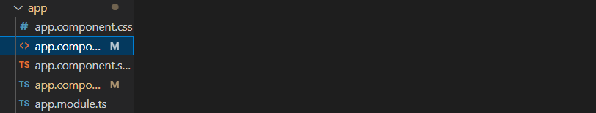
- This is the root file for any angular file.
- The angular is written in typescript and whenever it is rendered in the browser, it will be converted in javascript because typescript cannot be running in browser only js code will run in the browser.

